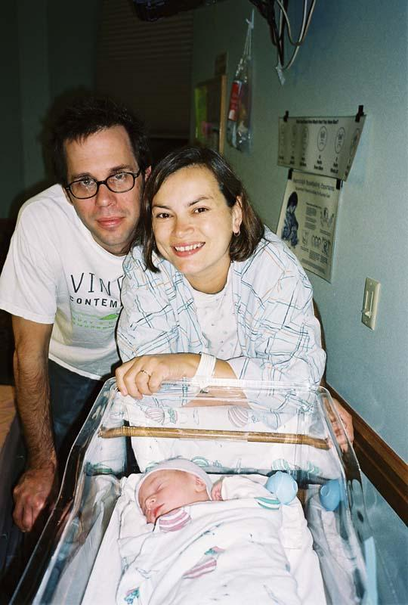

And baby makes three…
Alexander Kendall, Christine Marsh and Jack Kendall Fortney

http://webpages.charter.net/fortneymarsh/index.html

